Egilsay Bee fields come alive
The recent warm weather has brought an amazing buzz to the wildflower corridors and fields of our Onziebust reserve on the Island of Egilsay. The island is known for its diversity and numbers of breeding waders in Springtime, but from mid-June to August the landscape blooms with thousands of wildflowers and the bees begin to buzz.
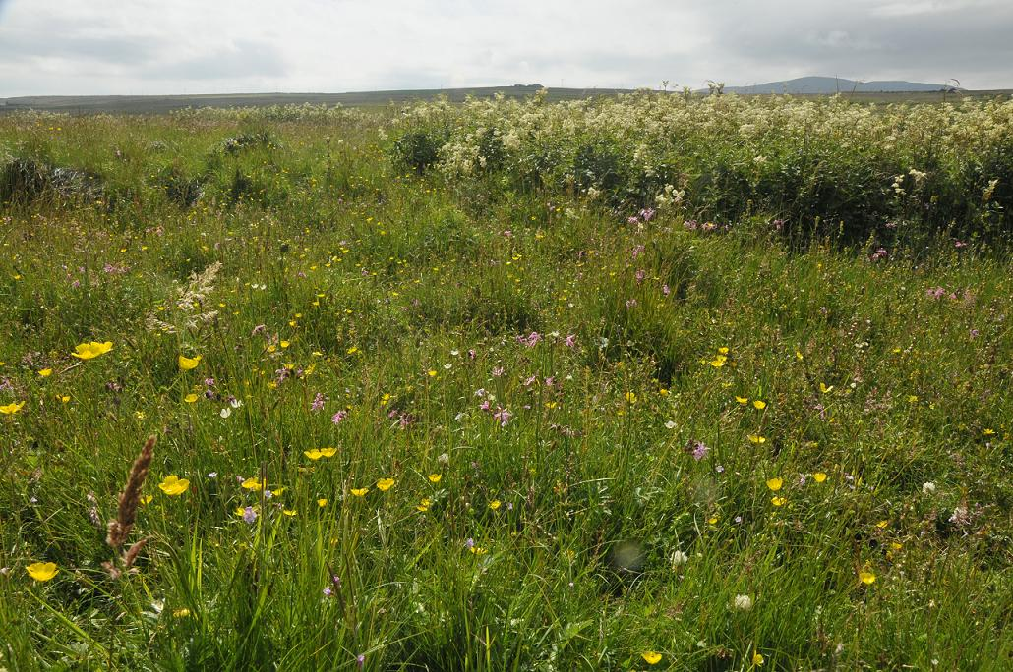
Wet meadow flora at its best. Tall white meadowsweet, pink ragged robin, vetches, buttercups, clovers, grass of Parnassus, orchids and many other flowers bloom.

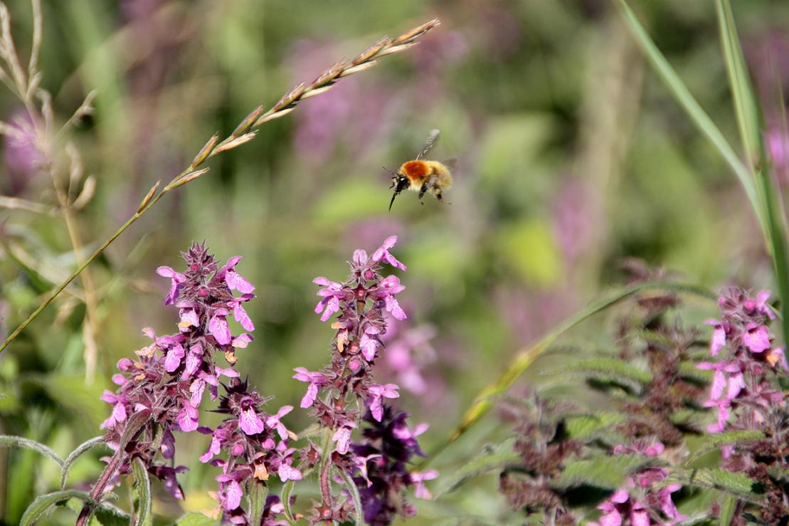
This picture was taken by our volunteer, Karen Dowers. It is a carder bee, either Bombus muscorum or pascuorum about to land on marsh woundwort, one of their favourite nectar and pollen providers. These plants are part of a ‘corncrake corridor’, sown to provide early Spring nesting cover for the birds and flowering plants for bees. Carder bees are so called as they carder (comb) vegetation such as moss to cover their nests on the ground.
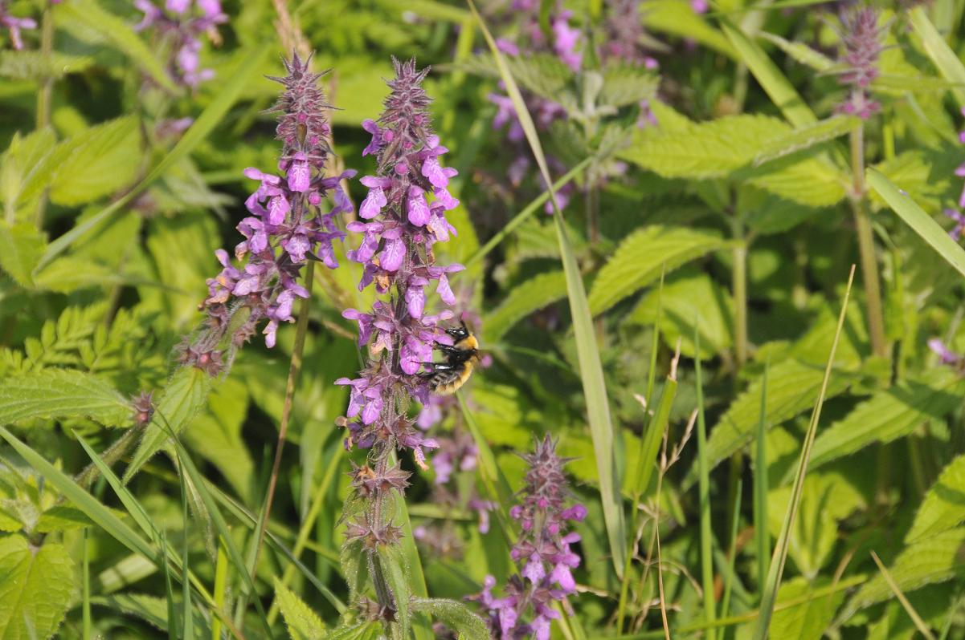
One of Britain’s rarest bees, the Great Yellow Bumblebee. This is a queen, big, with hairy golden yellow body and a black band, between the wings. The hairs on bumblebees do keep them warm! Thus, they are adapted for cooler climates, whereas tropical bees are hairless. Orkney and the Scottish western Isles are this declining bee’s last stronghold, sustained by sensitive farming and land management. They were once found throughout Britain.

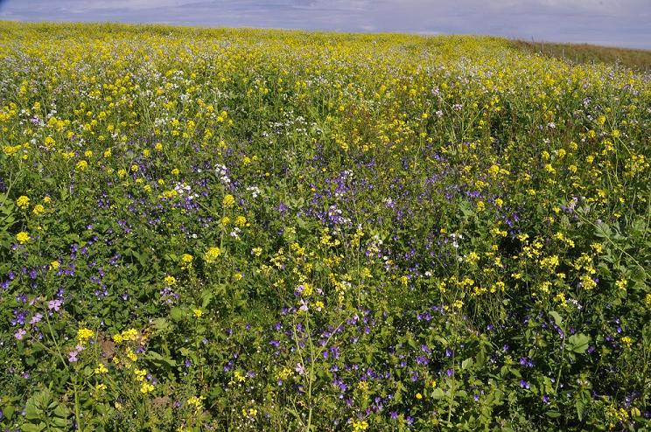
This is a crop, a crop sown to feed birds and bees. The seed mixture has been designed by the RSPB to feed invertebrates in the summer and finches, buntings and larks in winter. I live in the warden’s house just above the field and the flowers’ aroma drifts over on the southerly breeze. The bees and hoverflies cannot resist and their buzz on this warm August day could be heard 20 metres from the field, amazing. The yellow flowers are forage rape, the purple are heartsease pansy, the white and pink are forage radish. The rape and radish produce huge amounts of oil-rich seed which feeds flocks of up to 400 twite as well as many other birds through the winter. What a bird table!
Barry O’ Dowd (Onziebust Warden).

