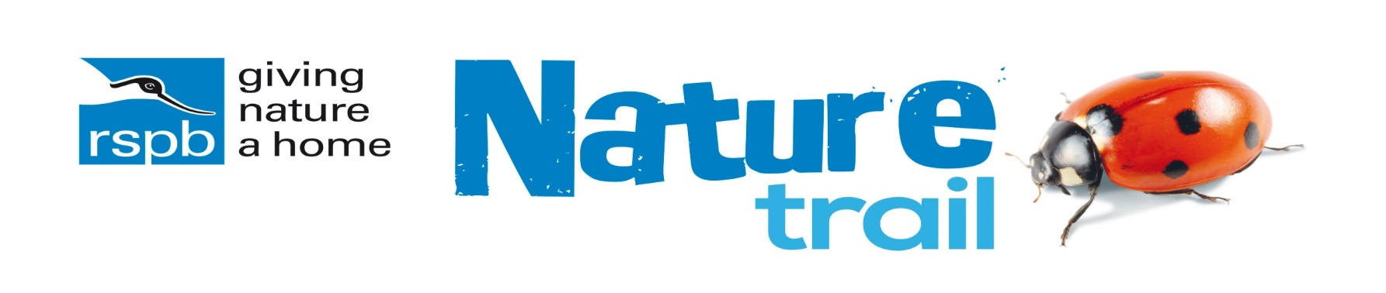
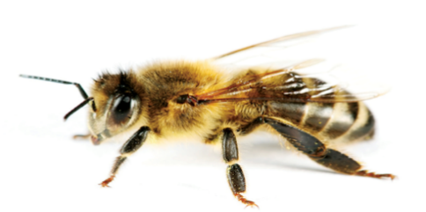

- Name a blue or purple flower that is loved by bees.

- Find a picture of a bumblebee – how many legs has it got?

- Why do you think bumblebees have thick hair on their bodies?

- What is special about the feet of bumblebees?

- Honey bees generally live in hives, where do bumblebees often make their nests?

- What name is given to the mother of all the bees in a nest?

- What do we call the sugary juice inside flowers that bees drink?

Look for a bumblebee flying around your garden or when on a walk. What colour is its tail? https://www.bumblebeeconservation.org/identify-a-bumblebee/ can help you to identify your bee.

Have fun!

