**Question 1: What do you think is the most important issue facing Wales in the future?**

**Please give your issue a title:** Nature loss

**Nature loss**

The *State of Nature 2016: Wales* report revealed that Wales is among the most nature-depleted countries in the world. It shows that in its current state, our environment cannot function effectively to provide for people and nature. Without healthy natural systems that support people and wildlife, we can’t secure food, materials, fresh water or clean air; we can’t prevent floods or climate change; and we can’t enjoy the outdoors through recreation or tourism; all of which benefit our physical and mental health and well-being.

As we watch our wildlife disappear from the hedgerow, rivers and our back gardens, we are watching our support system failing. But nature doesn’t just provide us with the fundamentals of life, it enriches our lives. Our experiences in the outdoors and with wildlife are cherished moments that shape our development as humans and help us to be more well and happy. We come from nature, we need nature, and nature needs us.

Please make sure you include nature loss as a priority for your team, because fixing it will guarantee a brighter future for the people of Wales.

***The following questions ask you to place a marker to indicate your answer on the relative importance of different things. We’ve set out our thinking to the answers next to each diagram.***

**Question 2. What needs to change to tackle the issue you've raised?**

|  |  |
| --- | --- |
|  | Doing existing things better and Make it a political priority are key.  There are important conservation tools that we haven’t used to their full potential. These include creating, protecting and managing wildlife sites. This has often been due to not having enough resources, partly because nature has not been seen as a political priority. |

**Question 3. What should be the role of the Future Generations Commissioner in tackling what you have said?**

|  |  |
| --- | --- |
|  | Holding to account and Influencing  The role of the Future Generations Commissioner should be to help remind public bodies of their responsibilities to the natural environment and support them in their delivery.  Guidance and advice are also important, of course, but other organisations including Natural Resources Wales may be better placed to provide this. |

**Question 4.Which organisations can have the most impact?**

|  |  |
| --- | --- |
|  | Government and Public Bodies  We all have a role to play, but Government and public bodies are key because of the influence they have – and can have - over both the private and voluntary sectors (e.g. through regulation, incentives and funding). |

**Question 5. What kind of people can have the most impact?**

|  |  |
| --- | --- |
|  | Politicians  We all have a role to play and we can all make a difference whether we be individuals managing our own gardens or community groups sharing resources. But we need our politicians – and particularly the Government - to show leadership and commitment to turning around biodiversity decline. |

**Can you suggest any specific organisations or other people that should be involved in making this change happen?**

The Welsh Government and public bodies including Natural Resources Wales and Local Authorities have key roles in developing policy, providing advice, managing land and regulating activities to help nature recover. Organisations like the RSPB, land managers including farmers, and businesses also have an important role to play.

**Question 6: Does the issue you raised relate to any of these big challenges? (Tick all that apply)**

We selected all of them

**Question 7: For each of the challenges, place a marker where you think it fits best** 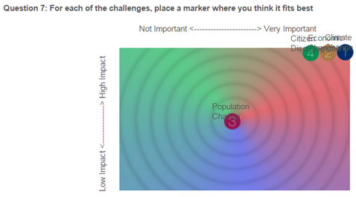

**Question 8. Is there anything important to you that’s missing from the challenges?**

Losing nature is a clear sign that our environment isn’t healthy and is a critical challenge that must be prioritised. Already, it has begun to affect our lives and will only get worse unless we take action. The Future Generations Commissioner has an important role in ensuring that protecting and restoring our natural environment is high up on the political agenda and to help remind public bodies of their responsibilities to the natural environment.

**Question 9. Is there anything else you want to say about the four challenges?**

You can provide any thoughts about the challenges here, or answer ‘No thank you’.

**Question 10. Who should pay attention to what you've said? (tick all that apply)**

We selected All of the above

**Question 11. What is the tone of what you've said?**Positive

The remaining questions are about you as an individual, and it is your choice whether you answer them or not. **Thank you** for taking part and letting the Commissioner know how important nature is to you.