What have we been up to?
Volunteers
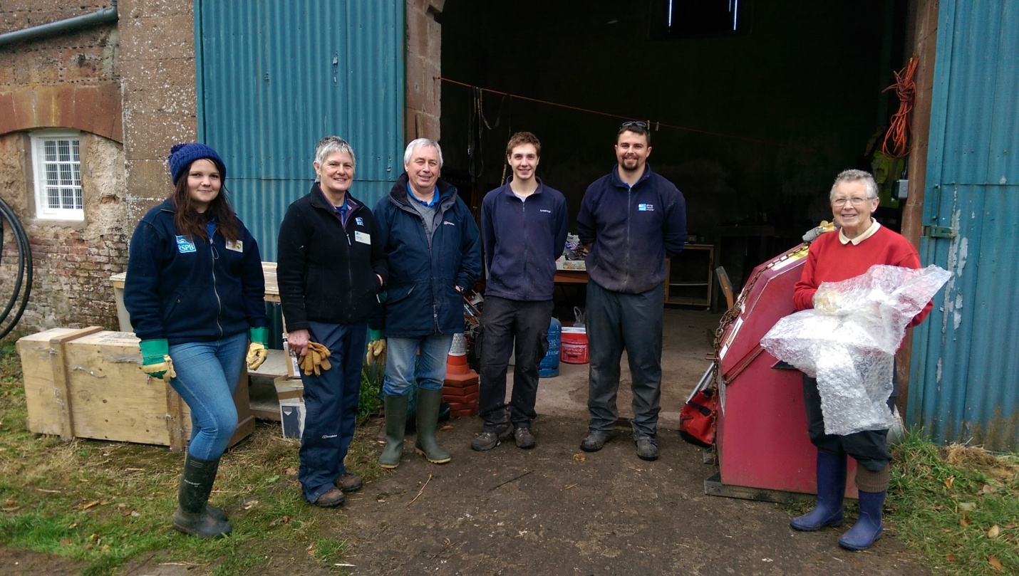
Left to right: Clare, Patricia, Peter, Josh, Tommy (Warden) and Pat.
Meet the team (see image above), of dedicated volunteers who are so important to the running of Kinnordy Loch. One of their jobs for October involved moving out of our old workshop and into our new, much larger unit (next door). Unfortunately in October we had to say goodbye to Clare (1st on left) who has moved on to her new Voluntary role working as a resident assistant warden at Insh Marshes. I personally wish her all the best for the future and know she will continue to make a great contribution to conservation.
A round up of Jobs
We have been busy topping our grazing compartments during August, stopping these areas from becoming areas of scrub and providing the reserves livestock easy access to graze. This allows us to maintain a low sward, providing Lapwing nesting opportunities during the breeding season. We have had our work cut out copping back vegetation from in front of the hides but the hard work will provide our visitors with a better chance of viewing wildlife within the reserve. The outflow channel has been the focus of my, and the volunteers, attention since the end of September. We have been busy cutting and pulling out vegetation and other debris to help with the flow of water leaving the loch. We have been concentrating our energy between the plug and sluice and will hopefully have this completed by the end of November before it gets too cold. The section from the sluice gate to the reserve boundary will be cleared using a digger this month.
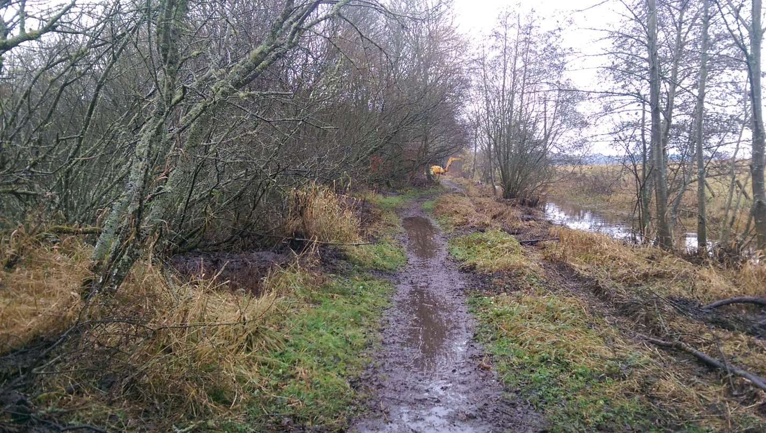
Outflow Channel Clearance

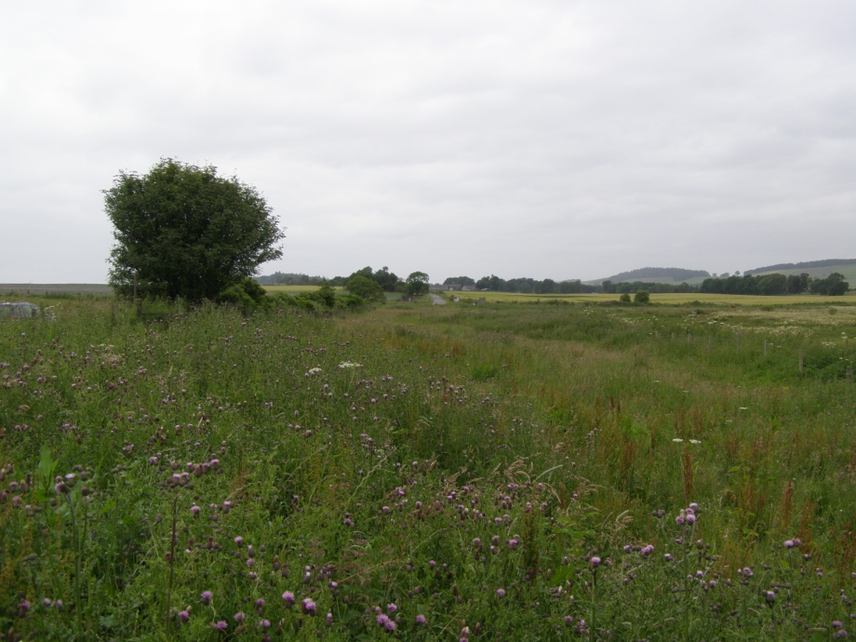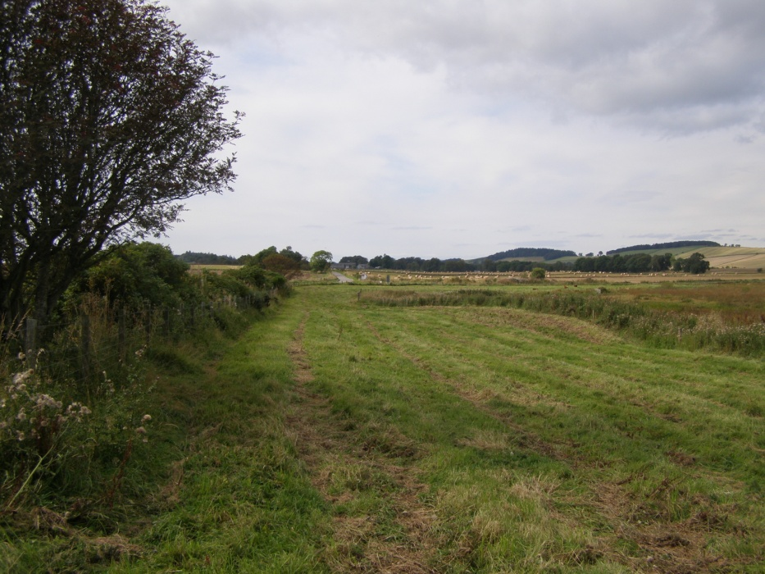
After Topping
Before Topping

Sightings
Sightings of bittern have started to roll in, with two individuals being witnessed together in late October. There have been sightings of bearded tits, a group of 12 being the largest observed with the latest sighting on the 22nd of November. Unfortunately we have had no Reports of smew on the Loch yet but the Loch does have a good verity of wildfowl at the moment including Tufted duck, Whooper and Gadwall. The path around the Loch is providing good views of Bullfinch and as always red squirrel.

