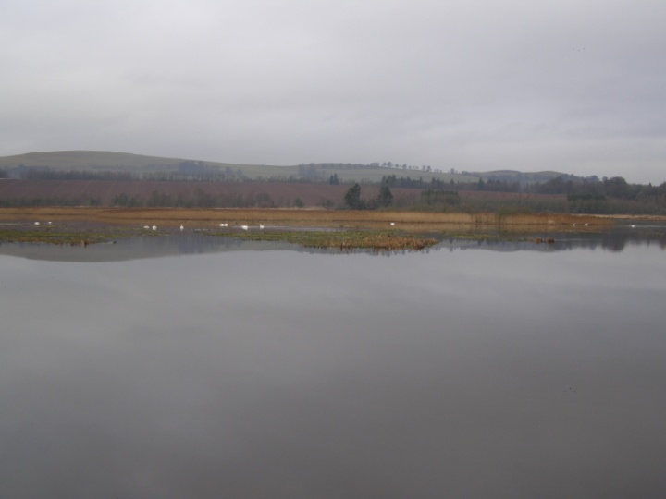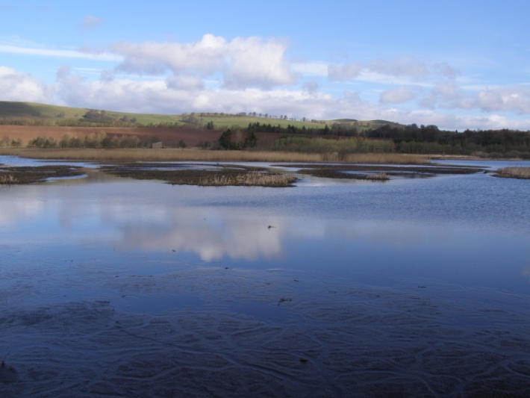
1) View from Gullery hide January 2014 2) View from Gullery hide April 2014

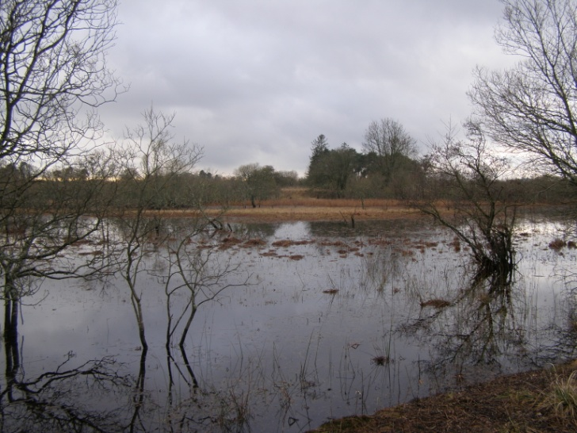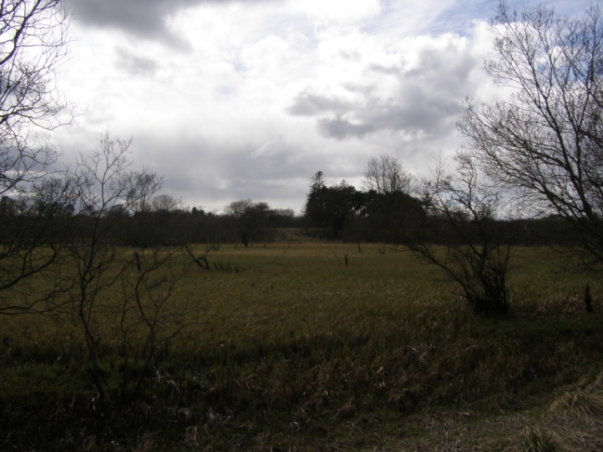
3) View from East end of reserve January 2014 4) View from East end of reserve April 2014

