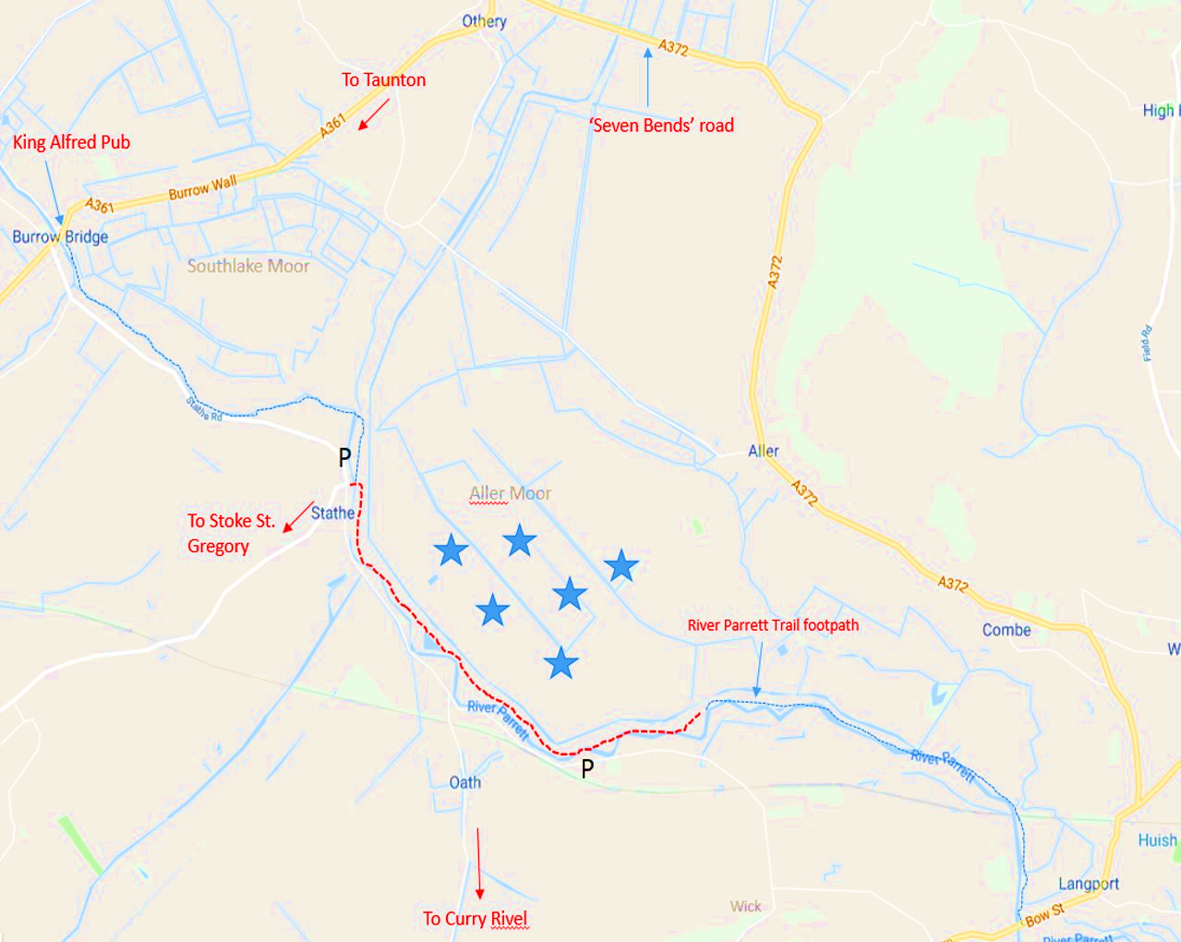

**Where to look for Cranes on the Somerset Levels**

The Somerset Cranes can be extremely elusive but autumn and winter is the best time to see them.

The best place to head for is the river Parrett at the village of Stathe.

Head along the A361 Taunton road to the village of Burrow Bridge (with a ruined church on a hill). In Burrow Bridge cross the bridge at the set of traffic lights by the king Alfred Pub and then turn immediately left.

Carry on along this narrow road for about 1.5 miles. There are a few pull in places near the junction to Stoke Gregory. From here walk up to the River Parrett trail.

**- - - - - - -** Foot path alongside river Parrett

Best spots for cranes

P Pull in spaces (please park

considerately)