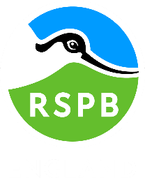
Volunteering opportunities available

We have vacancies for new volunteers in multiple roles!
Do you want to be part of a great team, learn new skills and be part of a great charity? if you do then please speak to a member of staff or contact Kirsty.scott@rspb.org.uk

