Event dates

Saturday 13 January 10.30am-Midday

Wild Challenge: Feed the birds

Saturday 10 February 10.30am-Midday

Wild Challenge: Wild weather

Saturday 10 March 10.30am-Midday

Wild Challenge: Upcycling for nature

Saturday 14 April 9am-10.30am

Wild Challenge: Sounds of spring

Saturday 12 May 9am-10.30am

Wild Challenge: Amazing moths

Saturday 9 June 10.30am-Midday Wild Challenge: Shake a tree

Saturday 14 July 10.30am-Midday

Wild Challenge: Pond dipping

Saturday 8 September 10.30am-Midday

Wild Challenge: Go on a bug safari

Saturday 6 October 10.30am-Midday

Wild Challenge: Trees, leaves and seeds

Saturday 10 November 10.30am-1pm

Willow bashing

Saturday 8 December 10.30am-3.30pm

Christmas party

Other Important information

**Who is the group for?**

The club is for children aged 5-12, who want to explore the natural world and have fun learning about all the wonderful things that live there. New members can join at any time, you don’t have to be a member of the RSPB and you don’t have to attend every meeting.

**When do we meet?**

We usually meet on the second Saturday of each month apart from August. Meetings take place between 10.30am-Midday unless stated otherwise.

**How much does it cost?**

There is a small charge of £2.50 for Wildlife Explorers members and £3 for children who aren’t members. All accompanying adults and accompanying children under five are free. Booking isn’t essential unless specified.

**What do I need to bring?**

As all meetings tend to have an outdoor component, please wear or bring warm, waterproof clothing (that you don’t mind getting mucky) and sturdy footwear to each meeting. Please bring binoculars if you have them too. We will endeavour to let you know of any additional requirements.

**How to contact us?**

**David White (Group Leader)**

RSPB Lakenheath Fen nature reserve

Station Road

Lakenheath

Brandon

Suffolk

IP27 9AD

Tel: 01842 863403

E-mail: [david.white@rspb.org.uk](mailto:david.white@rspb.org.uk);

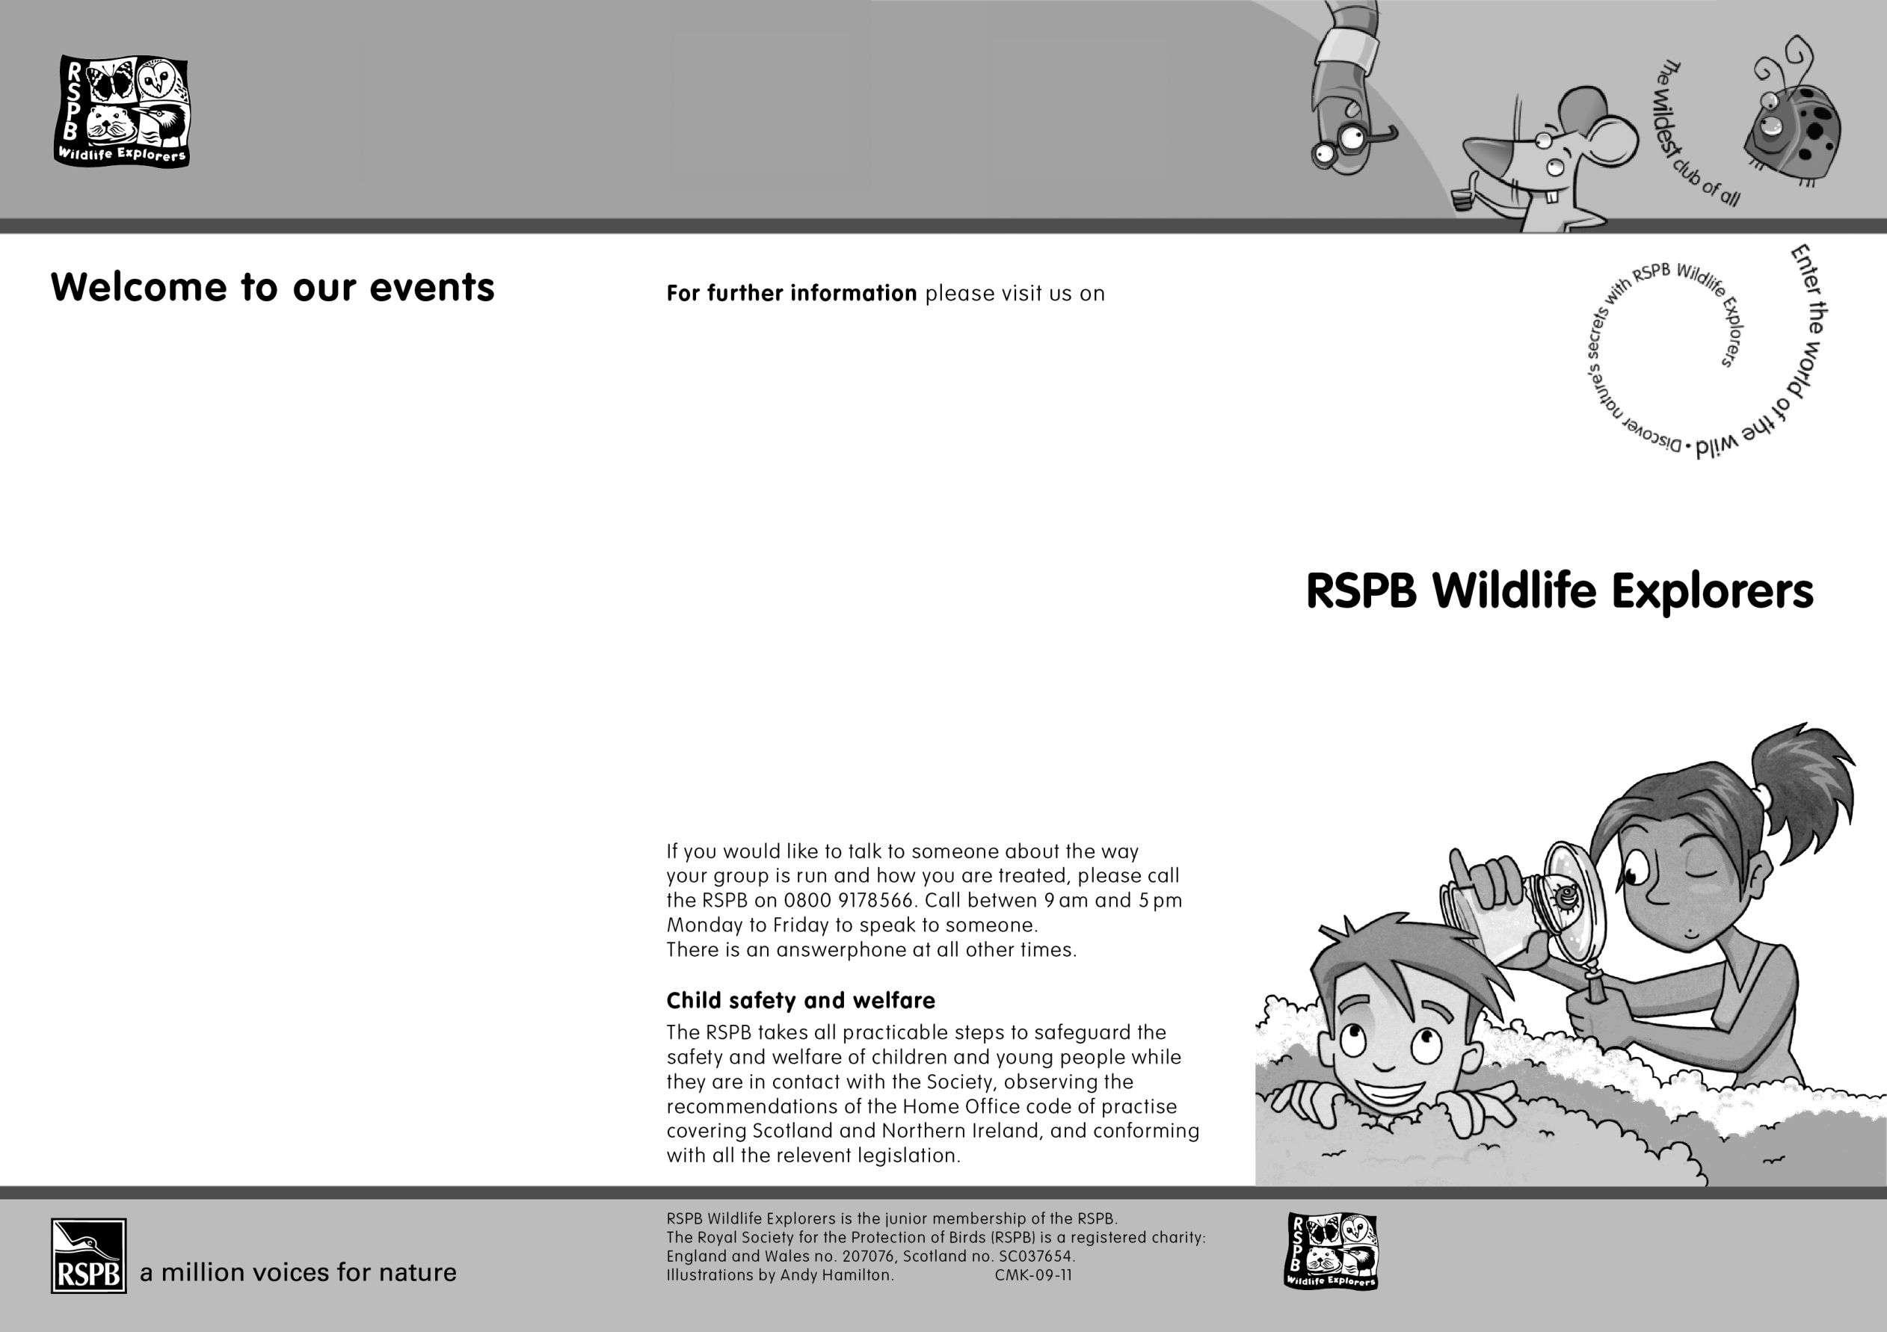



Lakenheath Fen

Wildlife

Explorers

Club

Events 2018



##### The Royal Society for the Protection of Birds (RSPB) is a registered charity: England and Wales no. 207076, Scotland no. SC037654

Willow bashing

Its willow bashing time again! In this longer than usual meeting, we will give the reserve team several pairs of helping hands by cutting some willow on the reserve. All tools and PPE will be provided. **Adults, please ensure that the children that are accompanying you wear clothes that you don’t mind getting mucky and wellington boots if possible.**

Christmas party

It’s almost Christmas so join us for a traditional Christmas party! There will be party games and the chance to get creative and make some Christmas cards. We will also make some Christmas gifts and there will be plenty of festive treats available for all attendees. Each child will also receive a small gift at the end of the session.

**Other family friendly events**

As well as the Wildlife Explorers Club, the reserve has a busy programme of events all year round. Please visit our website for more details: <http://www.rspb.org.uk/kakenheathfen>;

**Find us on Facebook**

[www.facebook.com/rspbsuffolk](http://www.facebook.com/rspbsuffolk);

**Children under the age of eight must be accompanied at all times. Parents, if you would like to leave children over the age of eight with us for the duration of the meeting, you will have to sign them in and out at the beginning and end of each meeting.**

**If you have any concerns**

If you would like to talk to someone about the way your group is run and how you are treated, please call the RSPB on 0800 9178566

**Child safety and welfare**

The RSPB takes all practicable steps to safeguard the safety and welfare of children and young people while they are in contact with the society, observing the recommendations of the Home Office code of practice covering Scotland and Northern Ireland, and conforming with all relevant legislation.

Wild Challenge: Amazing moths

In the second of our earlier than usual meetings, we will go through the moth traps that the reserve Wardens left out the previous night. We will see a selection of moths of all shapes and sizes and hopefully one or two impressive hawkmoths. If you are lucky, you may be able to hold a moth and release it. Please bring a camera if you have one as some of our moths are pretty spectacular!

**Wild challenge**: **Shake a tree**

This month, we will look for bugs by (gently!) shaking trees! We will find out creepy crawlies are living in our trees at this time of year. We will then do some quadrat surveys in the grass to find out what bugs are sneaking around in the grass. We are likely to find a selection of grasshoppers and crickets. We may even find the curiously named golden bloomed grey longhorn beetle, which looks positively extra-terrestrial.

Wild challenge: Pond dipping

Everybody loves pond dipping! This month, we will discover what monsters of the deep are lurking under the depths of the reserve pools. We will find pond skaters, water boatman and strange blood sucking leeches (which are completely harmless to humans by the way!) All nets, trays and identification sheets will be provided.

Wild challenge: Go on a bug safari

After the success of last September’s meeting, we will go on a bug safari around the reserve to look for spiders and other insects. We will see colourful marbled or weavers and four spot orb weavers. If we are lucky, we may even see a wasp spider, which is one of the reserve’s largest spider.

**Wild challenge: Trees, leaves and seeds**

In a meeting that is a week earlier than the usual date we will learn about the terrific trees that we have on the reserve. We will help the reserve team by removing some of the fallen leaves off of the path around the Brandon Fen family trail in advance of next week’s Race for Wildlife. We will then return to the visitor centre and make some leaf collages out of the materials that we have collected.

**Some more details!**

Wild challenge: Feed the birds

As the Big Garden Birdwatch is only two weekends away, we’ll be making fat ball feeders and other crafty creations to help our birds through the winter months. Afterwards we’ll take part in our own miniature version of the Big Garden Birdwatch in the visitor centre to find out which species are using the bird feeders.

Wild challenge: Wild weather

Have you ever wondered how to create your own lightning storm or fog in a jar?! Well join us this month to discover this and more as we take on the Wild Weather Challenge. After visiting the new weather station on the reserve we’ll return to the visitor centre to create our own weather recording equipment including a wind sock and rain gauge.

Wild challenge: Upcycling for nature

After we built “The Premier Insect” (our new bug hotel!) during last March’s meeting, we will continue to fill it with vegetation during this March’s meeting. We will collect a range of materials from various parts of the reserve and then put it in the bug hotel to make it nice and cosy for our resident creepy crawlies.

Wild Challenge: Sounds of spring

Mid-April is a great time to learn bird song. In this earlier than usual meeting, we will take a walk around the reserve and make a note of which species of birds we will hear singing. We will then return to the visitor centre and listen to some recordings of bird songs, just to see what you have learnt!