Image credit – Emma Cuthbertson

**Race for wildlife**

**RSPB Lakenheath Fen nature reserve**

**Sunday 16 October, race starts at 11am**

**(Registration closes at 10.30am)**

RSPB_logo_blacktext_Eng.emf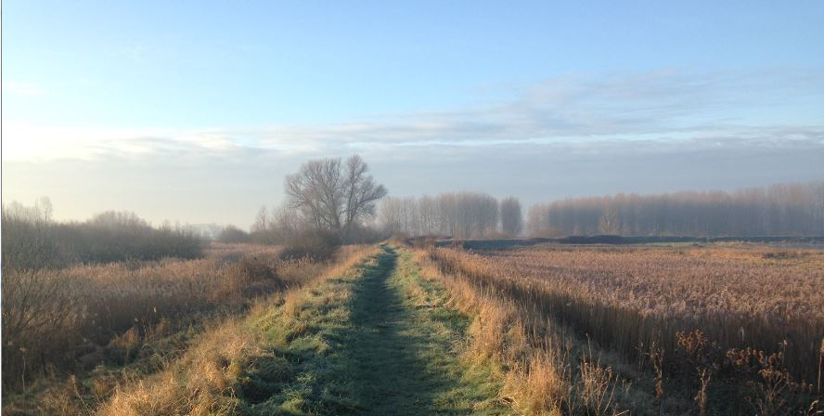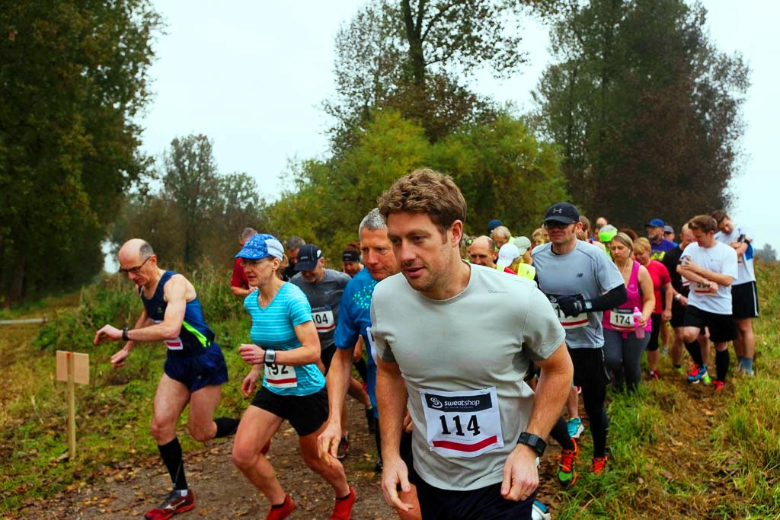

Image credit – Dave Rogers

Visit **rspb.org.uk/lakenheathfen**

The Royal Society for the Protection of Birds (RSPB) is a registered charity: England and Wales no. 207076, Scotland no. SC037654

**Cost**Please register in advance- **£10 entry:** via [www.wegottickets.com/lakenheath](http://www.wegottickets.com/lakenheath);

**How to get here**RSPB Lakenheath Fen nature reserve, IP27 9AD

Free parking at this event

**For more information call 01842 863400** or e-mail lakenheath@rspb.org.uk;

* Multi-terrain 5k and 10k courses around the reserve
* The 10k course follows routes normally closed to visitors
* Each participant will receive a **medal** and a **goody bag**
* **Homemade cakes** and refreshments for sale
* Toilets and secure baggage area

RSPB_logo_blacktext_Eng.emf

Image credit – Dave Rogers

**Race for wildlife**

**RSPB Lakenheath Fen nature reserve**

**Sunday 16 October, race starts at 11am**

**(Registration closes at 10.30am)**

Visit **rspb.org.uk/lakenheathfen**

The Royal Society for the Protection of Birds (RSPB) is a registered charity: England and Wales no. 207076, Scotland no. SC037654

* Multi-terrain 5k and 10k courses around the reserve
* The 10k course follows routes normally closed to visitors
* Each participant will receive a **medal** and a **goody bag**
* **Homemade cakes** and refreshments for sale
* Toilets and secure baggage area

**Cost**Please register in advance- **£10 entry:** via [www.wegottickets.com/lakenheath](http://www.wegottickets.com/lakenheath);

**How to get here**RSPB Lakenheath Fen nature reserve, IP27 9AD

Free parking at this event

**For more information call 01842 863400** or e-mail lakenheath@rspb.org.uk;

Image credit – Emma Cuthbertson