

Join in with the
Big Garden Birdwatch
At RSPB Fairburn Ings near Castleford
Sunday 30 January 11am – 3pm
Make your own‘green’ bird feeder
Guided garden bird walks on our Big Garden Birdwatch discovery trail

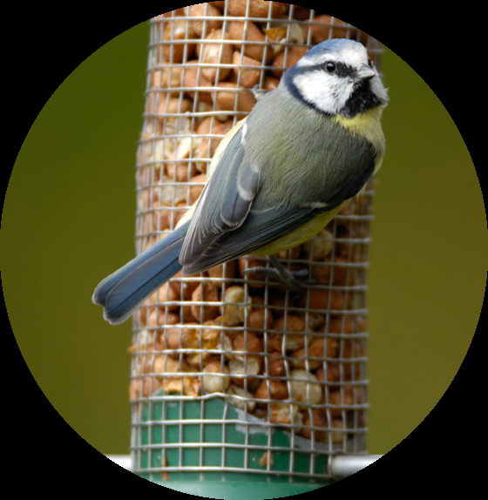
Find out the best ways of attracting garden birds at our Q&A Table
Make your own garden bird mask
Come and help us with our own Big Garden Birdwatch
Optics Demonstration

