How to add media to the community

How to add images to a post
To add an individual image to a post click on the “Insert” drop down. Within this you will have the option to Insert image/video file.
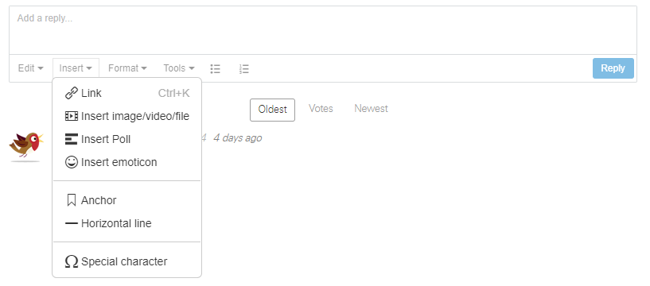
Within the window that opens select File Upload from the “From” dropdown.
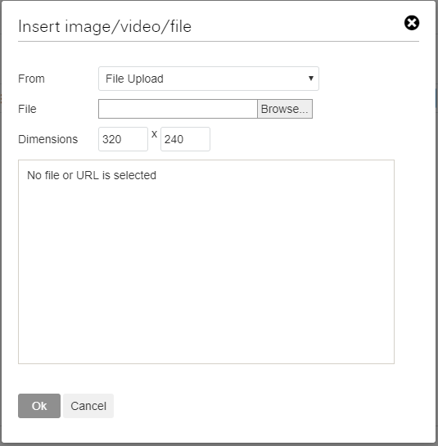
You can then browse your computer within the “File” field for your photo. Once selected clicking the Ok button will add it to your post.
To add multiple images to a post select all of the images you want to upload from your computer files.
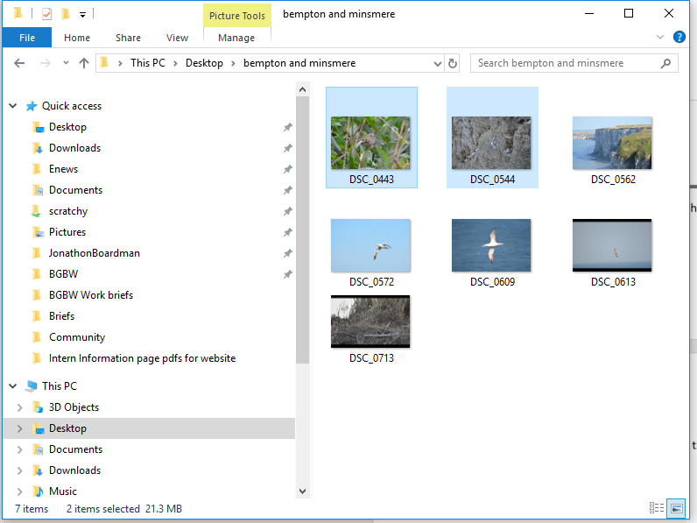
Then drag your selection into the edit field of your post.
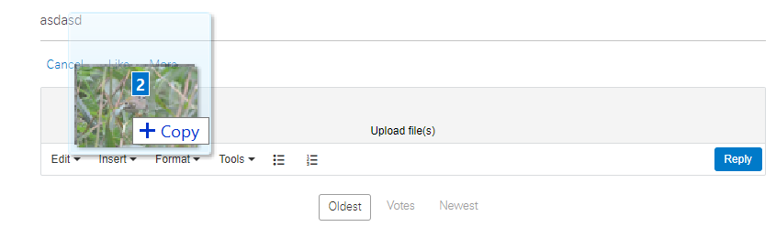
These will then appear in the edit field ready for posting. Please note that the more images and larger file size of the images will increase the time it takes to upload.

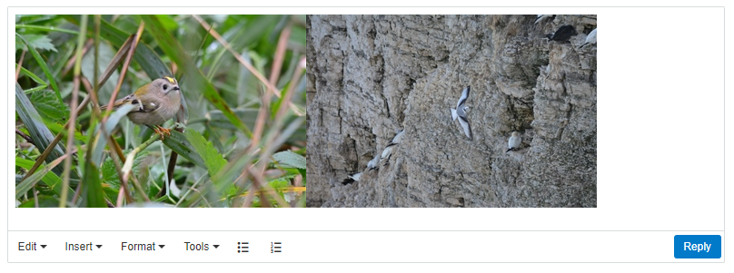

How to add to a media gallery
While in the gallery you want to add to click on the white “+ New” button in the top right hand corner.
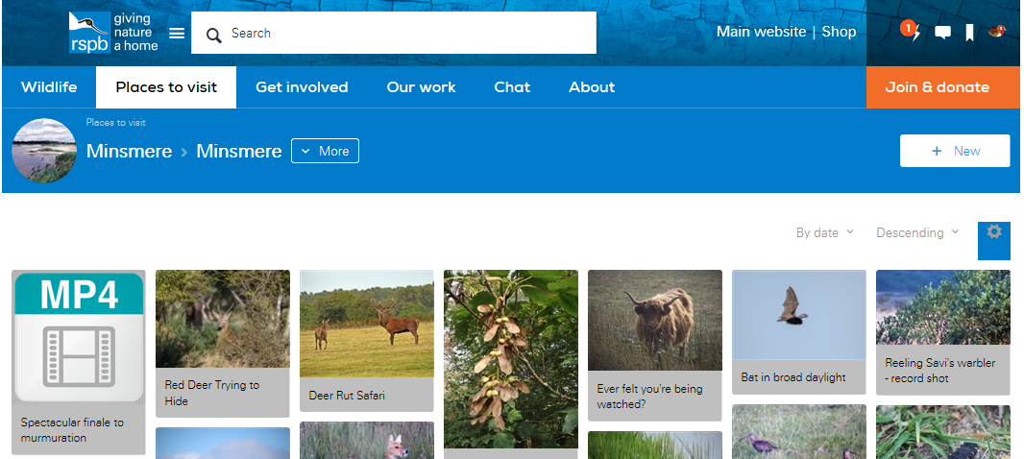
From within this page you will be able to browse and select your photo using the “Upload file” button.
You can also add a name, description and tags to your photo, before clicking the blue “Post” button to add your photo to the gallery.
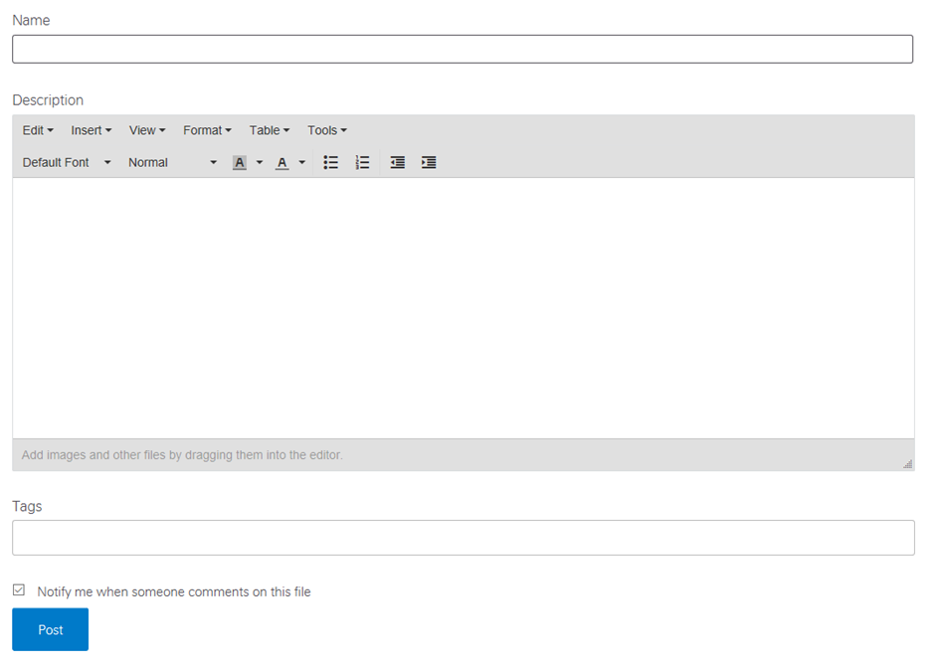

How to add a video to a post
To add a video to a post click on the “Insert” drop down. Within this you will have the option to Insert image/video file.
Within the window that opens select File Upload from the “From” dropdown.
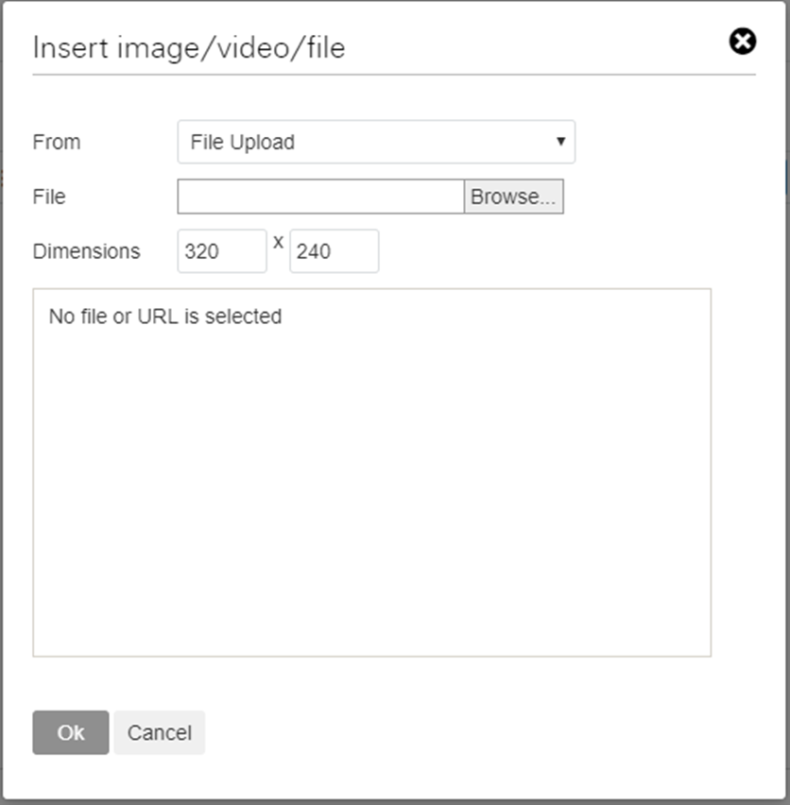
You can then browse your computer within the “File” field for your video. Once selected clicking the Ok button will add it to your post.
If your video is already on a streaming site such as Youtube or Vimeo you can include this by selecting Web (URL) from the “From” dropdown.
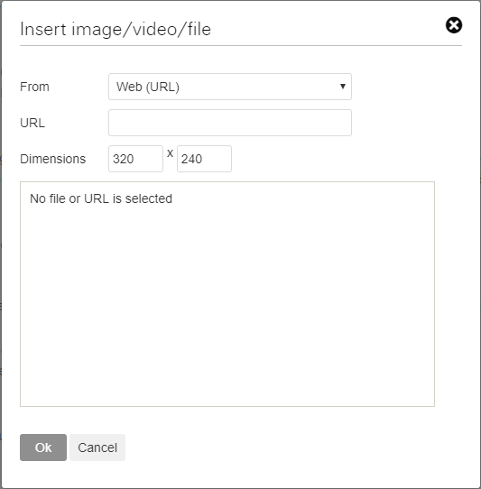
Here you can paste in the web address of your video into the “URL” field, then click the Ok button to add it to your post.

