WORK PARTY VOLUNTEERS
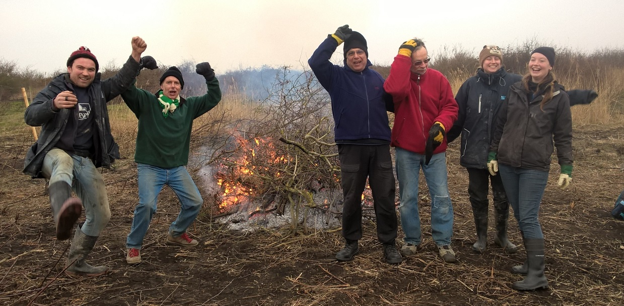

We are looking for enthusiastic friendly volunteers to join our weekly Thursday work party.
The work party goes out on to the reserves at Northward Hill, Cliffe Pools and Shorne Marshes each week to carry out a variety of practical tasks such as vegetation clearance, path maintenance, woodland clearance, having bonfires, infrastructure maintenance etc.
You don’t have to have particular skills, just lots of enthusiasm, energy, and a willingness to work outside all day.
If you fancy being part of a small friendly team and like the idea of outdoor practical work, getting fit and learning about nature conservation, or would like to know more about the role of work party volunteers, Ruby the Assistant Warden would love to hear from you.
Get in touch with her either by email at ruby.merriman@rspb.org.uk or on 07525 679699.
