The Barnies are back

On Sunday (September 29th) a small group of us were watching the high tide roost from the lay-by overlooking the salt marsh pool when we were delighted by our first sighting of barnacle geese this autumn. It’s always a thrill to have them back again. Some were grazing on the marsh to the west of the pool, others flying in small groups.
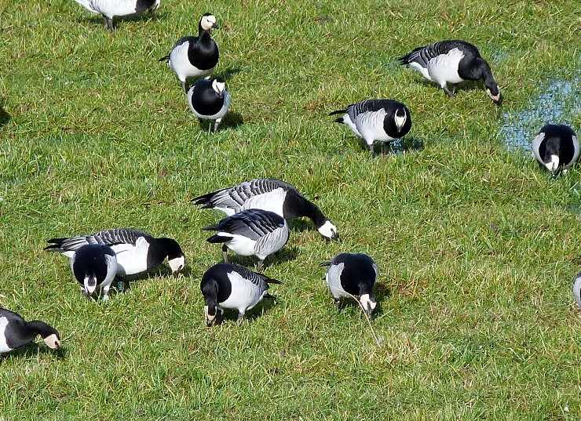
There were good numbers of oystercatchers roosting on the edge of the marsh, along with knot, curlew, lapwing, bar-tailed godwits, redshank and a solitary turnstone and ruff. The peregrine perched up on one of the fence posts seemed to ignore the waders, she must have had her lunch already.

The Thursday Volunteers have been busy recently with a variety of jobs on the reserve. We have cleared some of the invasive birch scrub from the Moss to stop it drying out the bog and weeded along the base of young hedges to help them grow. The Vols searched for marsh fritillary butterflies, then later for their caterpillars (and found both). To help the marsh fritillaries we’ve also planted more of their food plant, devil’s bit scabious.
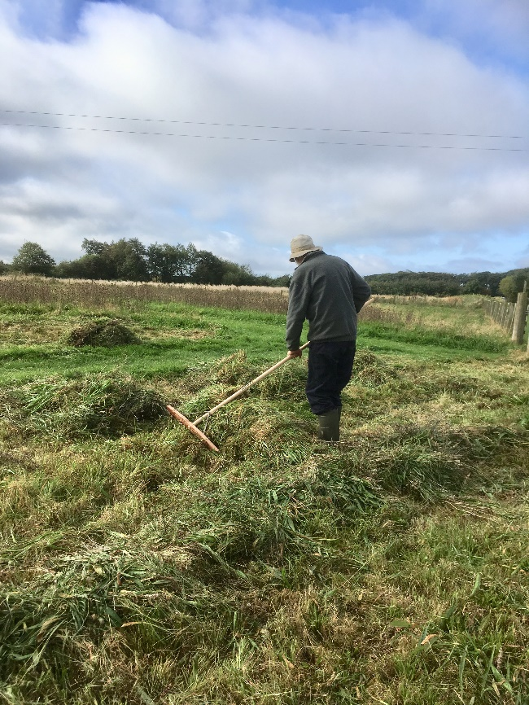
More recently we’ve raked up hay from the wild flower strips in the Discovery Field and spread it on other areas to distribute the seed, and sown a special fenland seed mix along a new low bund on the edge of the bog.

Diggers are very busy on the reserve just now, creating fantastic big scrapes in the fields. These are wetting up already and the viewpoints being created should give really good views of the waders which will come in when the work is finished (soon). In the meantime the blue trail has been temporarily closed but the Discovery Field and dipping pond are still readily accessible. The red trail is still open and the blue trail will reopen as soon as possible.
Marjorie Hutchin

